Supplementary Materials for: Floral development in an Andean bellflower (*Centropogon granulosus*, Campanulaceae) and pollination by Buff-tailed Sicklebill (*Eutoxeres condamini*)

Note: All data and scripts used in this study have been deposited in the Dryad Digital Repository (https://…)

#### Phenological modeling

To model flowering phenology of *C. granulosus*, we fit the following linear model to the rate of anthesis and senescence for each inflorescence that produced at least five flowers ( $n$ = 5 controls, $n$ = 5 pollinator excluded):

$$n_{i}=β_{0}+β_{1}*days+ϵ$$

   Where $n_{i}$ is the cumulative number of flowers produced on an inflorescence at $days$ = $i$, $β_{0}$ is the intercept, $β_{1}$ is the flowering rate, and $ϵ$ is the residual error.

   To determine if pollinator exclusion affected the total number of flowers produced, we fit the linear model:

$$n_{total}=β_{0}+β_{1}*treatment+ϵ$$

   Where $β_{0}$ is the intercept, $β_{1}$ is a coefficient, and $ϵ$ is the residual error.

Figure S1. Fused anther hairs forming a scale and serving as a lever to deposit pollen (red arrow). This individual has finished the male phase and is in transition to the female phase — the stigma will continue to extend past the scale and unfold when receptive (white arrow).

Figure S1. Fused anther hairs forming a scale and serving as a lever to deposit pollen (red arrow). This individual has finished the male phase and is in transition to the female phase — the stigma will continue to extend past the scale and unfold when receptive (white arrow).

Figure S2. Trait matching in Buff-tailed Sicklebill and C. granulosus observed at the study site. Photo used with permission from J. Heavyside (UBC).

Figure S2. Trait matching in Buff-tailed Sicklebill and C. granulosus observed at the study site. Photo used with permission from J. Heavyside (UBC).

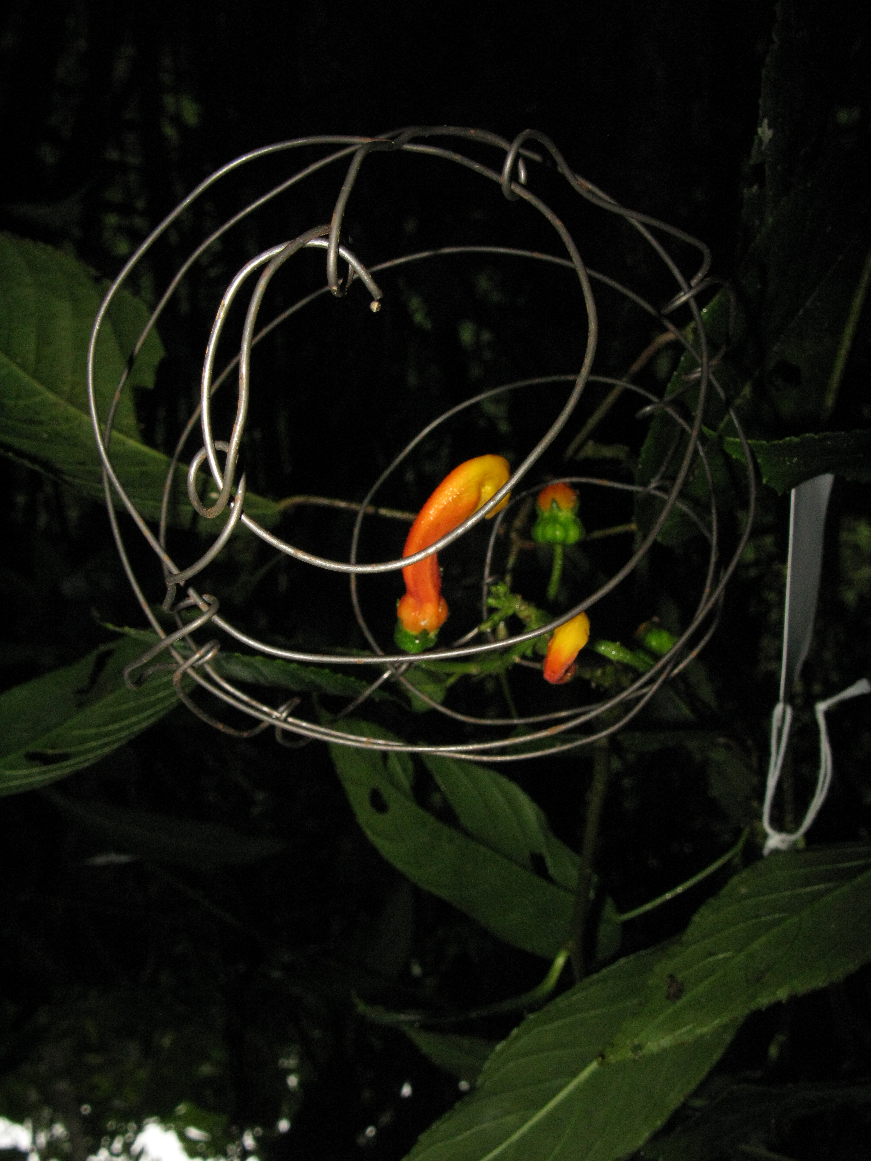

Figure S3. Wire cages used to exclude avian visitors from accessing the nectaries of C. granulosus. Further details on the design can be found in Sun et al. (2017).

Figure S4. Still frames extracted from a video recording of E. condamini pollinating C. granulosus. A: The hummingbird approaches and inspects an inflorescence without any open flowers. B: A second inflorescence with an open flower is approached. C: To insert its bill, E. condamini hovers below the flower opening and tilts its head backwards. D: During feeding, its head is at eye-level with the corolla opening and the anther/stigma is in contact with the crown.

Figure S4. Still frames extracted from a video recording of E. condamini pollinating C. granulosus. A: The hummingbird approaches and inspects an inflorescence without any open flowers. B: A second inflorescence with an open flower is approached. C: To insert its bill, E. condamini hovers below the flower opening and tilts its head backwards. D: During feeding, its head is at eye-level with the corolla opening and the anther/stigma is in contact with the crown.

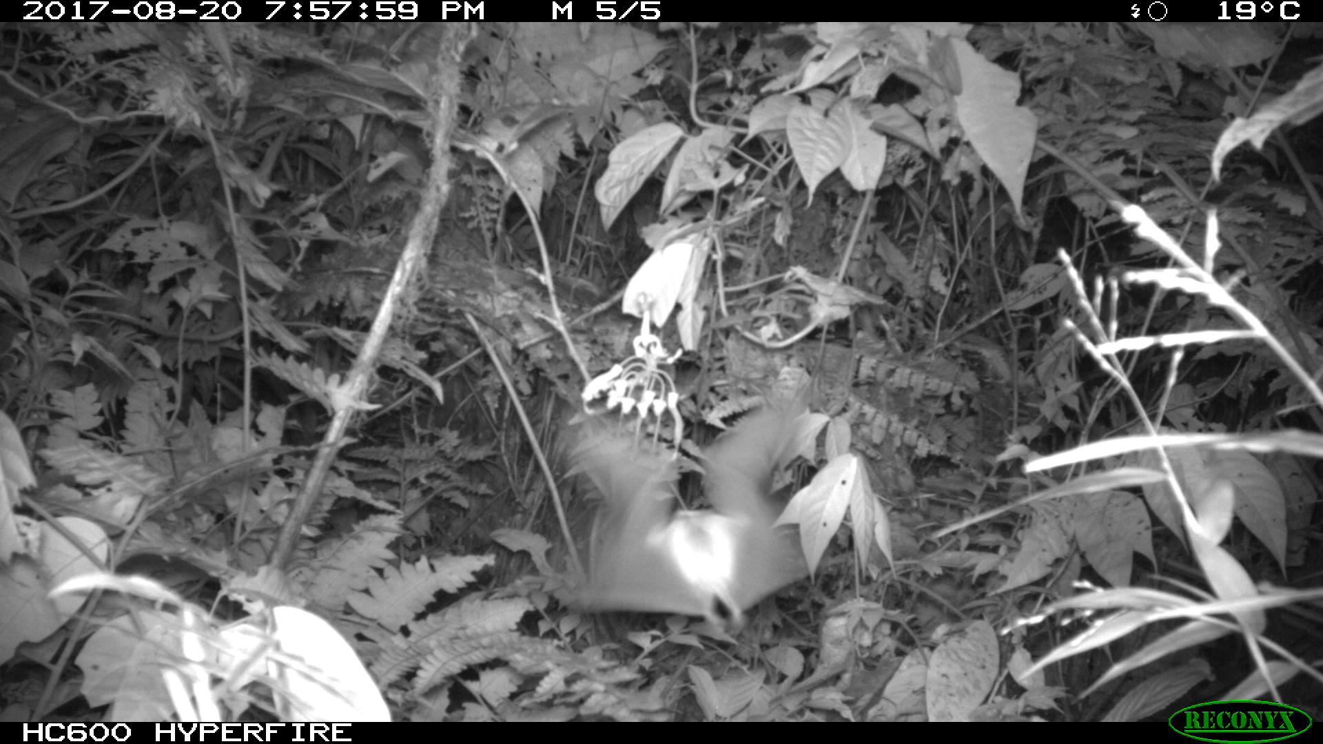

Figure S5. A long-nosed bat (Glossophaginae) recorded near an inflorescence of C. granulosus with several developing berries.

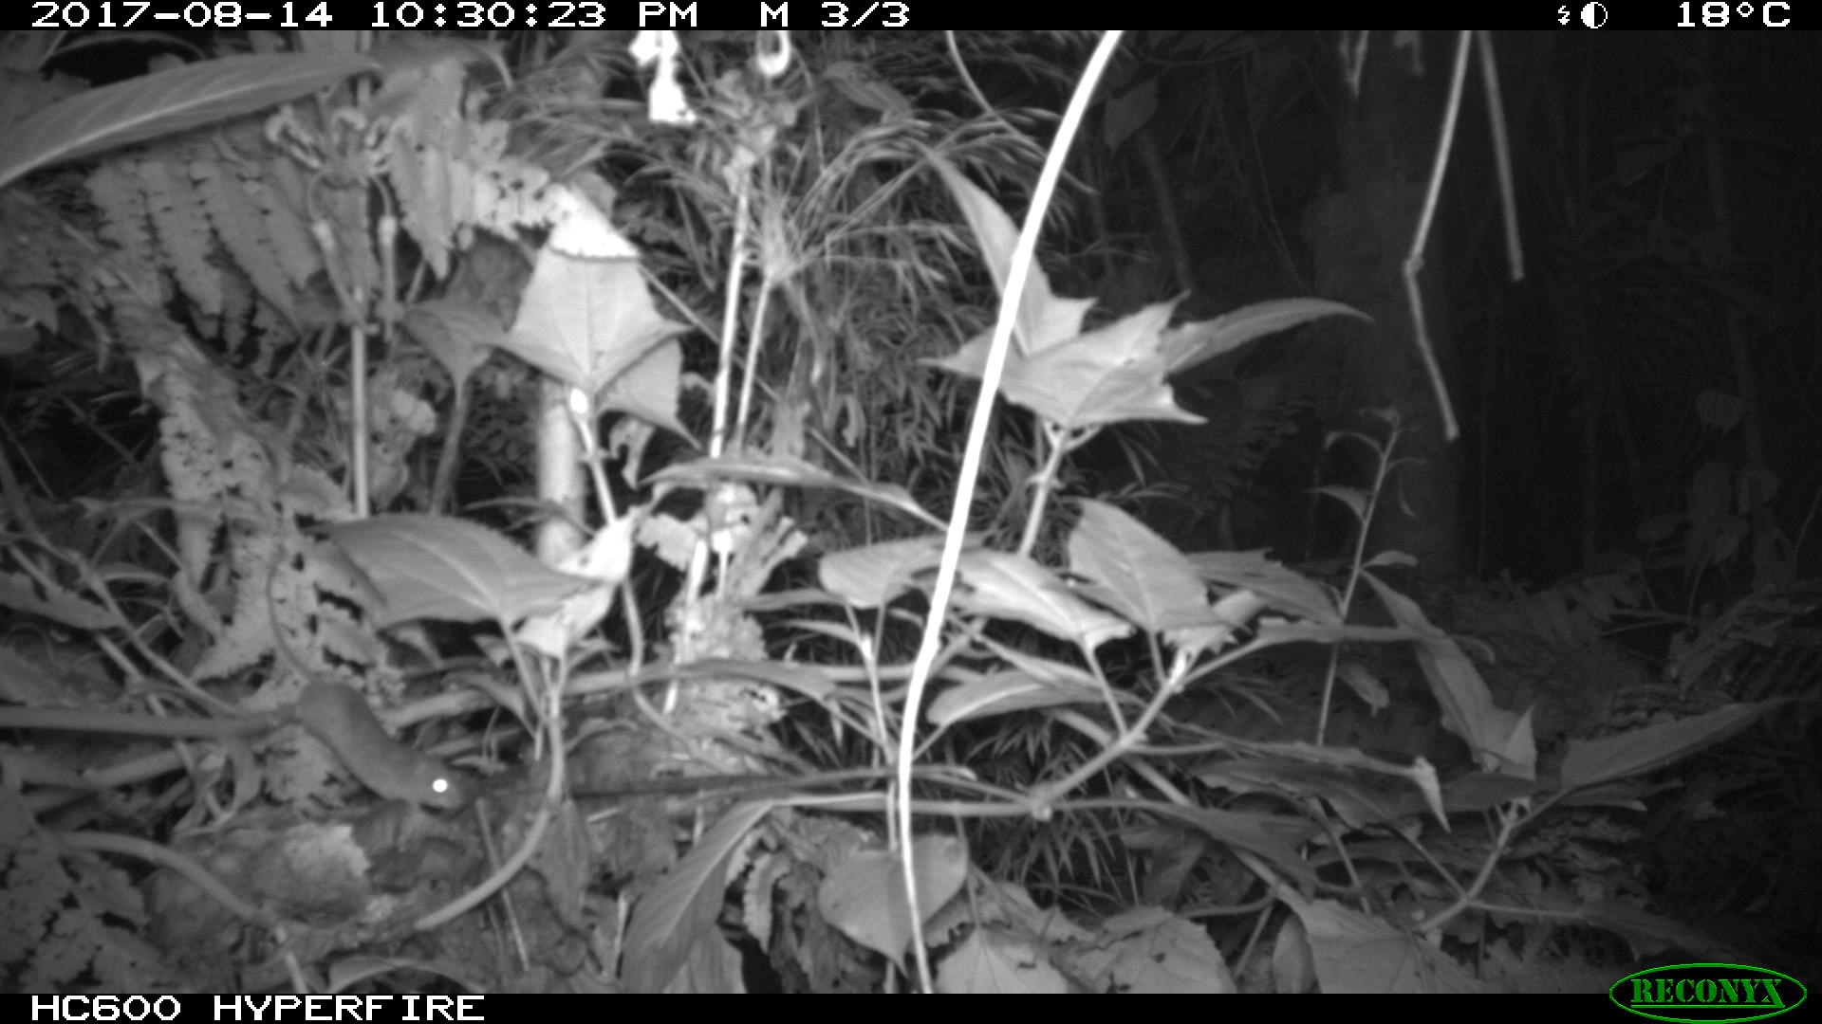

Figure S6. A rodent (Muridae, bottom left) recorded near an inflorescence of C. granulosus (top left) with several developing berries.

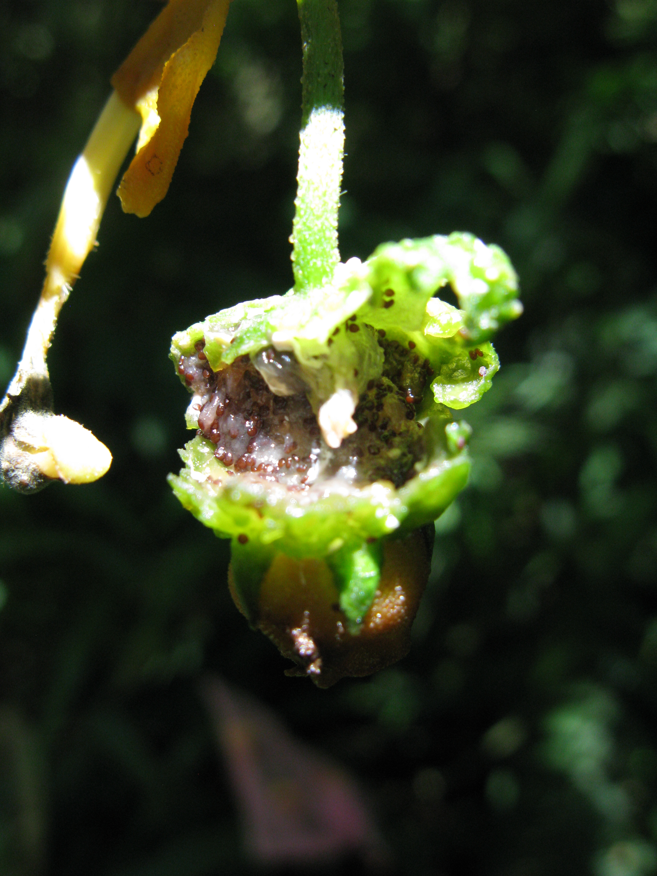

Figure S7. Signs of frugivory of a C. granulosus berry.

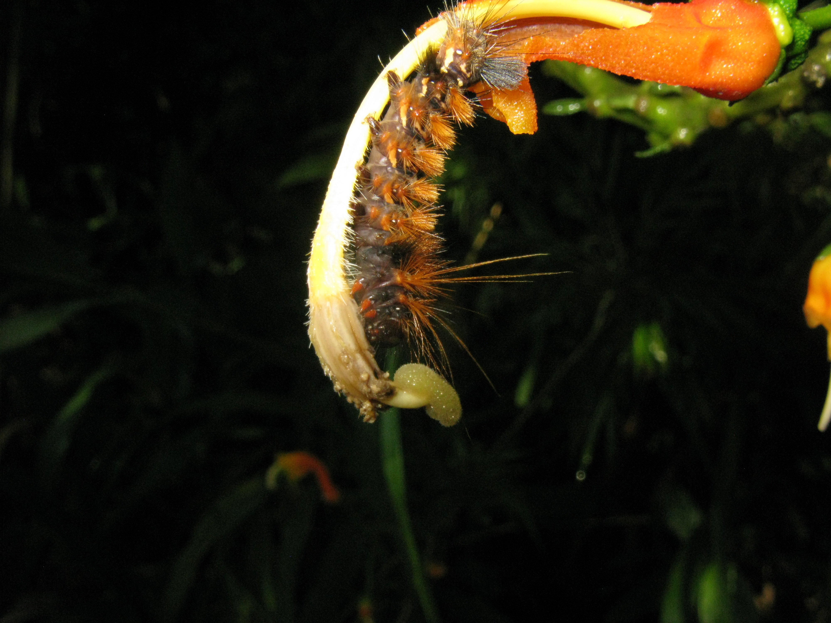

Figure S8. Herbivory of a C. granulosus flower by a larval lepidoptran.

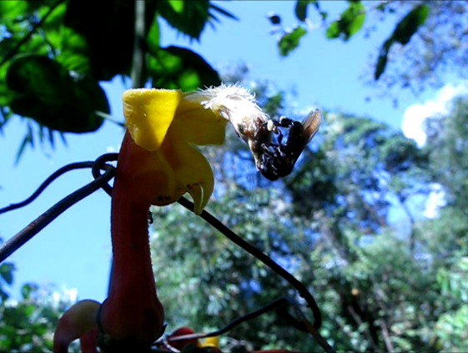

Figure S9. A stingless bee (Meliponini) collecting pollen from an anther scale of C. granulosus.

Figure S10. Inflorescence of C. granulosus with a multitude of peduncle scars (red arrow) suggestive of an extended flowering peak.

Figure S10. Inflorescence of C. granulosus with a multitude of peduncle scars (red arrow) suggestive of an extended flowering peak.

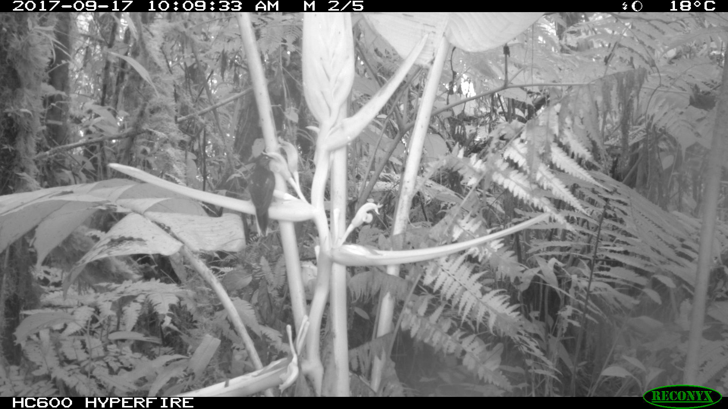

Figure S11. Buff-tailed Sicklebill visiting Heliconia aemygdiana Burle-Marx, and using the floral bract as a perch during feeding.



*Figure S12. Recorded visits to C. granulosus by Buff-tailed Sicklebill. Visit data is compiled from six C. granulosus individuals (see: Table S3). 'AM' is defined as 12:00am-11:59am and 'PM' is 12:00pm-11:59pm'.*

Table S1: Locations in San Pedro monitored for Sicklebill visitation to C. granulosus. The first column lists the C. granulosus individual identifiers.

|  |  |  |  |
| --- | --- | --- | --- |
| ID | latitude | longitude | elevation |
| CNTRPGN 1-10 | -13.05684 | -71.54469 | 1306.706 |
| CNTRPGN 11 | -13.05603 | -71.54515 | 1301.995 |
| CNTRPGN 12-15 | -13.05928 | -71.54773 | 1381.661 |
| CNTRPGN 16-20 | -13.05900 | -71.54666 | 1323.870 |
| CNTRPGN 21-23 | -13.05921 | -71.54690 | 1330.937 |
| CNTRPGN 24-32 | -13.05932 | -71.54778 | 1345.147 |
| CNTRPGN 33-41 | -13.05821 | -71.54805 | 1359.792 |
| CNTRPGN 42 | -13.05720 | -71.54699 | 1370.250 |
| CNTRPGN 43-50 | -13.05728 | -71.54672 | 1368.063 |
| CNTRPGN 51-53 | -13.05563 | -71.54676 | 1358.099 |
| CNTRPGN 54-60 | -13.05696 | -71.54784 | 1398.831 |

Table S2: Stages of floral development in C. granulosus.

|  |  |  |
| --- | --- | --- |
| Stage | Description | Median duration (days) |
| A | Flower primordia appears above bracts. No curvature and red-orange pigmentation is not continuous around the base. Flower up to 9 mm tall (as measured from the top of the bracts). Basal diameter up to 4 mm. | 22.3 |
| B | Initiation of curvature, creating 90 degree angle. Red-orange pigmentation is continuous around the base. Flower up to 10 mm tall. Basal diameter up to 6 mm. | 6.1 |
| C | Growth phase. 180 degree angle formed. Red-orange pigmentation outweighs yellow. Flower 14 to 20 mm tall. Basal diameter 6 - 8 mm. | 6.3 |
| D | Pre-anthesis. >180 degree angle formed. Flower 30 mm tall. Basal diameter 7 - 8 mm. | 8.6 |
| E | Anthesis. Mature male-phase flower. Flower 34 -36 mm tall. Basal diameter 7 - 8 mm. | 2.6 |
| F | Female-phase flower. Pistil grows overtop of the pollen trap. Flower up to 36 mm tall. Basal diameter up to 10 mm. | 2.4 |
| G | Senescing flower. Petals wilting but retained. Basal diameter 8 - 10 mm. | 5.3 |
| H | Berry development. Petals senesced and lost. Basal diameter grows from 11 - 17 mm. | 24.2 |

Table S3: Camera trap records of E. condamini.

|  |  |  |  |  |  |
| --- | --- | --- | --- | --- | --- |
| Date observed | Time of day | Feeding mode | Temperature (Celsius) | Centropogon ID | Flower ID |
| Aug_18_2017 | 12:36 | hovering | 19 | 1 | 1 |
| Aug_22_2017 | 10:38 | hovering | 21 | 1 | 1 |
| Aug_22_2017 | 10:38 | hovering | 21 | 1 | 2 |
| Aug_22_2017 | 15:54 | hovering | 20 | 1 | 1 |
| Aug_22_2017 | 10:39 | hovering | 20 | 2 | 1 |
| Aug_23_2017 | 10:24 | hovering | 19 | 1 | 2 |
| Aug_24_2017 | 7:17 | perching | 17 | 1 | 1 |
| Aug_24_2017 | 7:17 | hovering | 17 | 1 | 2 |
| Aug_25_2017 | 16:27 | inspecting | 19 | 3 | NA |
| Aug_26_2017 | 5:52 | hovering | 15 | 4 | 1 |
| Sep_15_2017 | 5:24 | hovering | 16 | 5 | 1 |
| Sep_16_2017 | 5:56 | inspecting | 15 | 5 | NA |
| Sep_19_2017 | 5:36 | perching | 14 | 5 | 2 |
| Sep_19_2017 | 7:15 | perching | 16 | 6 | 1 |

Table S4: Camera trap records of S. geofryii.

|  |  |  |  |  |  |
| --- | --- | --- | --- | --- | --- |
| Date observed | Time of day | Feeding mode | Temperature (Celsius) | Centropogon ID | Flower ID |
| Sep_11_2017 | 9:58 | hovering | 20 | 7 | 1 |
| Sep_11_2017 | 13:03 | hovering | 22 | 7 | 1 |
| Sep_11_2017 | 13:55 | hovering | 23 | 7 | 1 |
| Sep_11_2017 | 15:01 | hovering | 23 | 7 | 1 |
| Sep_11_2017 | 16:11 | hovering | 22 | 7 | 1 |
| Sep_14_2017 | 10:44 | hovering | 21 | 7 | 2 |
| Sep_14_2017 | 11:42 | hovering | 22 | 7 | 2 |
| Sep_14_2017 | 13:10 | hovering | 21 | 7 | 2 |
| Sep_14_2017 | 14:32 | hovering | 21 | 7 | 2 |
| Sep_14_2017 | 16:54 | hovering | 21 | 7 | 2 |

# References

Sun, S.-G., Z.-H. Huang, Z.-B. Chen, and S.-Q. Huang. 2017. Nectar properties and the role of sunbirds as pollinators of the golden-flowered tea *Camellia petelotii*. *American Journal of Botany* 104: 468–476.